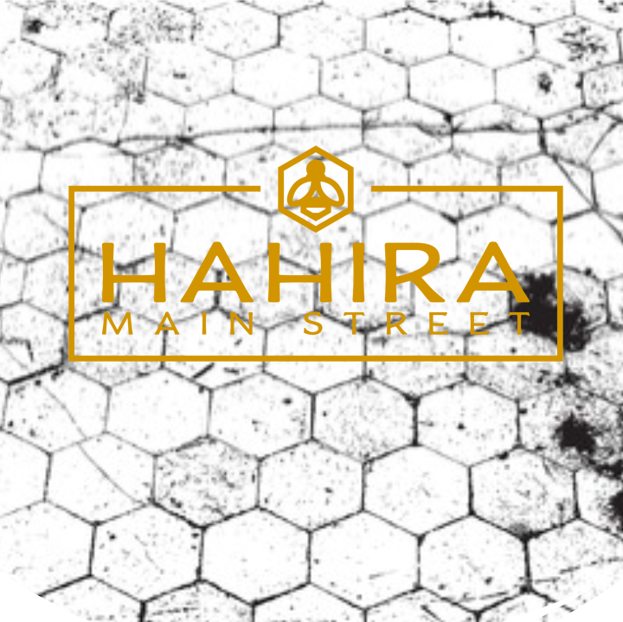
HAHIRA HYPE TEAM APPLICATION
Do you love downtown Hahira? Are you ready to share the hype?
Join the downtown Hahira Hype Team! The Downtown Hahira Hype Team is composed of community members who share a passion for the progress happening in downtown and a desire to promote it. Hype Team members serve as ambassadors during large events held in downtown Hahira. They work as a united front to welcome visitors downtown, answer any questions visitors may have, and encourage people to use #downtownhahira when posting about their positive experience downtown.
Fill out the application below to join!

Your Name

Email

Phone Number

Address

Facebook

Why do you want to join Downtown Hahira’s Hype Team?

NOMINATE FUTURE TEAM MEMBERS
Know someone who would make an excellent Hype Team member? Let us know! Share their name and contact information so we can reach out to them.
Name

Phone Number

Email

STATEMENT OF UNDERSTANDING
- I am not guaranteed a position on the Hype Team by filling out this application.
- If selected to join the Hype Team, I agree to sign up for and attend 4 events annually to perform my Hype Team duties.
- If selected to join the Hype Team, I agree to speak positively about downtown Hahira on my social media accounts.
By signing my name below, I understand and agree to the statements above:

