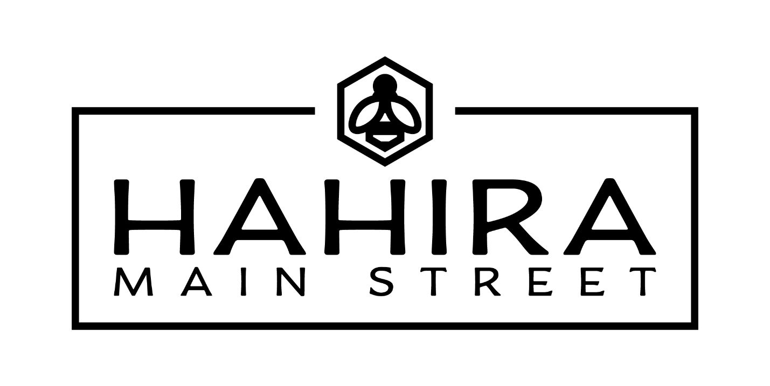
JOIN THE #DOWNTOWNHAHIRA HYPE TEAM!
Overview
The Downtown Hahira Hype Team is composed of community members who share a passion for the progress happening in downtown and a desire to promote it. Hype Team members serve as ambassadors during large events held in downtown Hahira. They work as a united front to welcome visitors downtown, answer any questions visitors may have, and encourage people to use #downtownhahira when posting about their positive experience downtown.
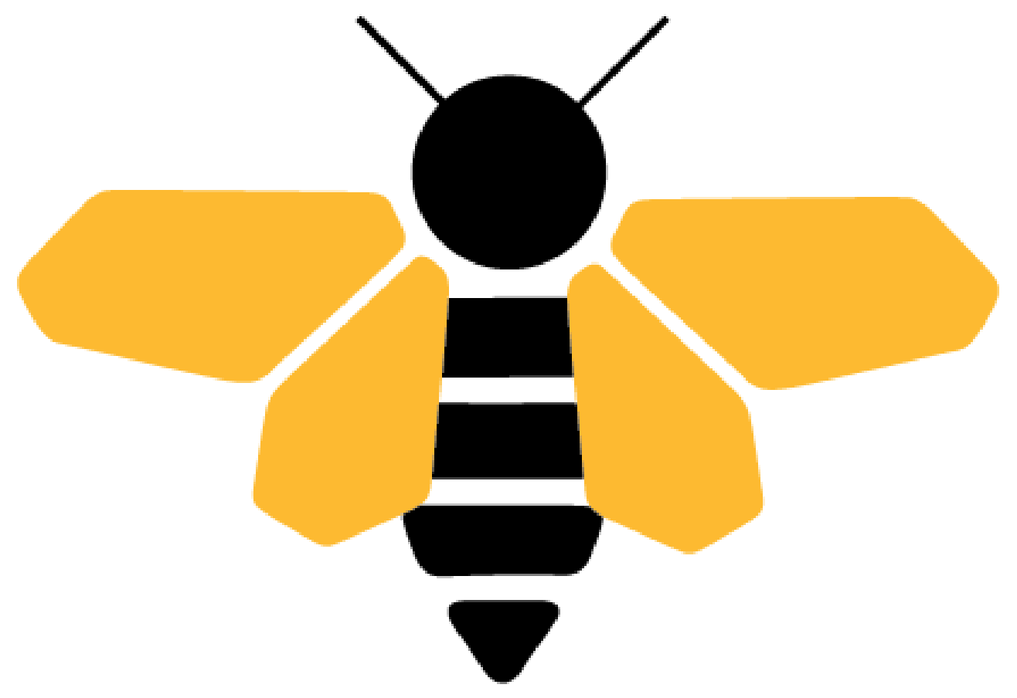
The Hype Team is an initiative of Downtown Hahira’s Main Street Board of Directors.
Expectations
Hype Team members should be friendly, accommodating, and knowledgeable about downtown Hahira’s businesses and events. This is a group of people who love downtown Hahira and are in the know about all the great things happening downtown!
Ideal Team members are those who are willing to initiate a conversation with visitors who look like they need directions or recommendations and are willing to promote downtown Hahira via their social media channels throughout the year.
Hahira residents of all backgrounds, ages, and abilities are invited to apply to be part of the Hype Team. The main requirements are a positive attitude and an infectious enthusiasm for downtown.
Commitment
Hype Team members will be given a schedule of events annually and are expected to complete a 2-hour shift at 4 events throughout the year. Team members will be able to sign up for events based on their schedule’s availability.
Events
The Hype Team will work as ambassadors during major events held downtown. This includes Spring Downtown, the Chili Cook Off, the Independence Celebration, Christmas and holiday events throughout the season, Farmers Markets and much more!
Application
Those interested in joining the Hype Team and have the time to commit fully to the Team are encouraged to apply!
Contact
Ready to share the hype? Contact Jamie Parr at msintern@hahiraga.gov for more information.

